The JP Club House… Historical Site?
I found this in a random internet search under Seattle Historical sites. Hope it is of interest. Photos from the JP Mens Club website.
Dick Rovig
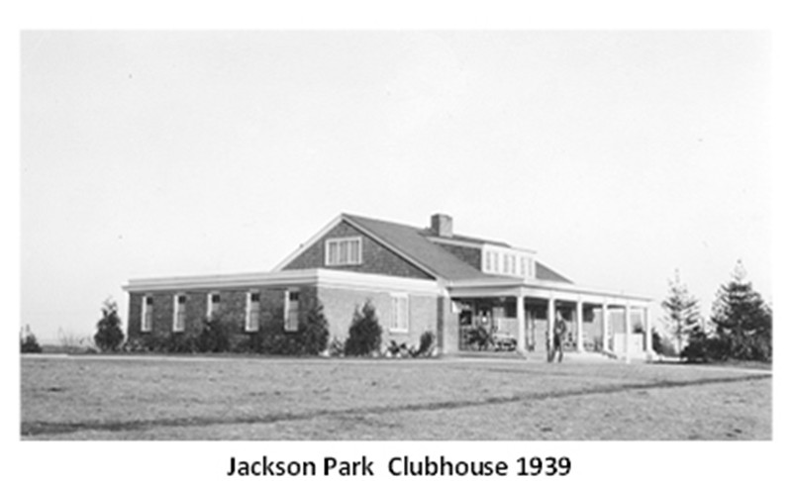
Significance
In the opinion of the survey, this property appears to meet the criteria of the National Register of Historic Places.

Completed in 1930, this rambling brick golf clubhouse was the original building constructed for this purpose at the Jackson Park Golf Course, which opened on May 12, 1930. This was exactly fifteen years to the day after the first municipal golf course opened at Jefferson Park.
This area was first settled in the mid-1880s after Minerva A. Jones purchased a large farm tract from W.B. Denny in 1884. The Jones’ Tract was bounded by NE 135th and NE 145th Streets and 5th and 20th Avenues NE, comprising most of the future site of the Jackson Park Golf Course.
By 1894, the area was connected to the city of Seattle far to the south via a poor, wagon road, which continued onto Bothell at the northern end of Lake Washington.
In the early 1920s, the Jones heirs platted the eastern half of their holdings into the Paramount Park Addition. The western half was sold to realtor M. Ray Wood of Seattle. At the time, this area was well beyond the northern limits of the city at 85th Street. Since 1891, the city’s northern limits had been set at 85th Street between 8th Avenue NW and 15th Avenue NE, then considered a great distance from the center of town in Pioneer Square.
Twenty years later, the city had annexed Ballard on the west and portions of Ravenna and Laurelhurst on the east. Over the next thirty years, the city’s population shifted further to the north and to the northeast, pushing into the unincorporated areas.
In 1928, there was a strong petition to annex the Jackson Park area to the city, however the opposition was stronger. The area remained part of unincorporated King County until 1954 when the City of Seattle annexed it along with the adjacent Lake City district.
By the mid-1920s, there were twelve private golf courses in King County but only the one public course at Jefferson Park on Beacon Hill. Due to the increasing popularity of the game, residents of the north end petitioned the Parks Board to develop a second facility.
In 1927, the Parks Board accepted an offer from M. Ray Wood to sell his 140-acre brush-covered stump land for $66,000, which included the clearing of the fairways. An additional fourteen acres were later purchased and developed into a short-nine course in 1954.
The Parks Board hired Francis L. James of New York and Philadelphia to design the new "North End Golf Course," which would be accessible via private automobile and public bus.
Before the first nine holes opened on May 12, 1930, the new golf course was renamed for President Andrew Jackson after the community had suggested numerous possibilities. The course’s remaining nine holes were completed the following year.
Designed with Colonial Revival stylistic features, the course’s brick clubhouse contained the usual amenities, including a refreshment and clubroom, separate locker rooms for men and women, and an apartment on the second floor of the center main block.
Since the construction of this building, many additions and alterations have been made. However, the building is significant for its design and for its association with the development of Jackson Park Golf Course.

Appearance
Completed in 1930, this one and 1½-story building occupies a site at the top of a slight hill near the southeast corner of the Jackson Park Golf Course. The wood frame and brick masonry structure faces southwest towards the southern end of the 18-hole golf course.
Exhibiting Colonial Revival stylistic influences, the building features a 1½-story, side gable center block flanked by one-story flat roof wings capped by wide cornice. Both wings were the same lengths originally until the southern wing was enlarged with an addition at the southern end. An angled covered walkway connects this structure to a restaurant constructed in 1970-71.
On the principal west elevation of the main block, the original projecting porch has been enclosed with large multi-paned picture windows set at angles between wide brick piers. The original slender Doric columns, which supported the flat roof, are still visible on the interior of the building behind the brick piers, which separate this elevation into five bays. Double wood entrance doors are situated with the center bay. An additional single entrance door is located on the northern side of the enclosed porch.
As part of the same alterations, small projecting entrance bays were added at the corners on either end of the enclosed porch. The doors within these bays provide access from the exterior to the end wings, which house locker rooms for women and men.
A narrow flat roof supported by tapered wood piers covers these entrances and wraps onto the enclosed porch, where it extends across the façade above the windows. Wood shakes clad the gable ends of the main block as well as the side walls of the shed roof dormers on both the front and rear elevations. The rear dormer retains the three original multi-paned wood windows, while the front dormer has a large clock within the center opening between replacement windows at either end. The original multi-paned windows within the gable ends have also been replaced. The rear east elevation of the main block has a series of horizontal multi-paned windows which alternate with a vertical window and an entrance door.
A stairwell leads down to another entrance at the lower basement level. The northern end wing containing the women’s locker room facilities has a pair of multi-paned windows in a single opening on the west elevation, five 4/4 double hung windows across the north elevation, and a single multi-paned window on the rear east elevation.
The west and east elevations of the southern end wing present blank brick walls with the exception of a small shed roof addition at the northern end of the east elevation. Clad with horizontal wood siding, this small structure has a door on the eastern side and a multi-paned window on the southern side. The south elevation contains three 4/1 double hung windows and an entrance door at the eastern end. It appears that the original windows were reused in the new end wall of the later addition.
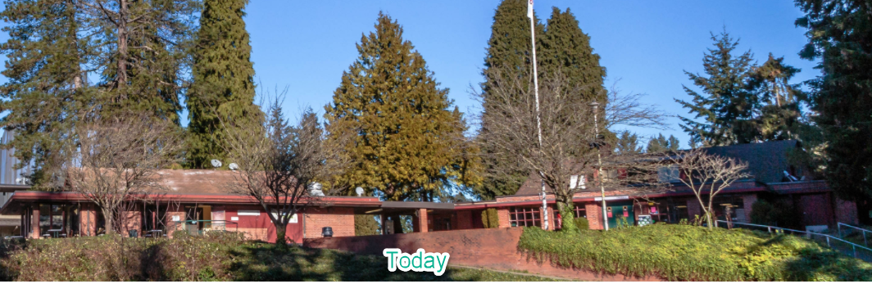
. Despite the extensive alterations noted above, this well maintained building retains relatively good physical integrity.

